|  |  |
| --- | --- |
|  | SR UNIVERSITY  Campus Warangal |
| Program: II - B.Tech (CS& AI) |
| Professor(a): Dr. Venkataramana Veeramsetty, Professor |
| Department: Computer Science and AI Semester: I |
| AI Assisted Coding - Lab Test 1 - Set B |
| Instructions:   1. Use AI Tools like VScode+Github Copilot and Cursor AI for code generation 2. This Assignment will be evaluated for 15 Marks (10 Marks for Tasks and 5 Marks for viva based on regular lab activities) 3. Students need to submit assignment through canvas before due date 4. Students who are absent for lab will receive 0 Marks | |

1. Create a Python function that converts an amount from one currency to another using exchange rates stored in a dictionary. Use GitHub Copilot along with VS Code. Use Few shot prompting.
2. Write a Python program to extract all email addresses from a block of text using regular expressions. GitHub Copilot along with VS Code. Use zero shot prompting.
3. Given a list of movies with their genres, Write a Python function that recommends movies based on a user’s preferred genre. Use the Cursor AI tool. Use few shot prompting.
4. Write Python code that reads a CSV file containing student names and marks in 3 subjects. Calculate the total and average marks for each student. Use the Cursor AI tool.

Date: 2025-08-14

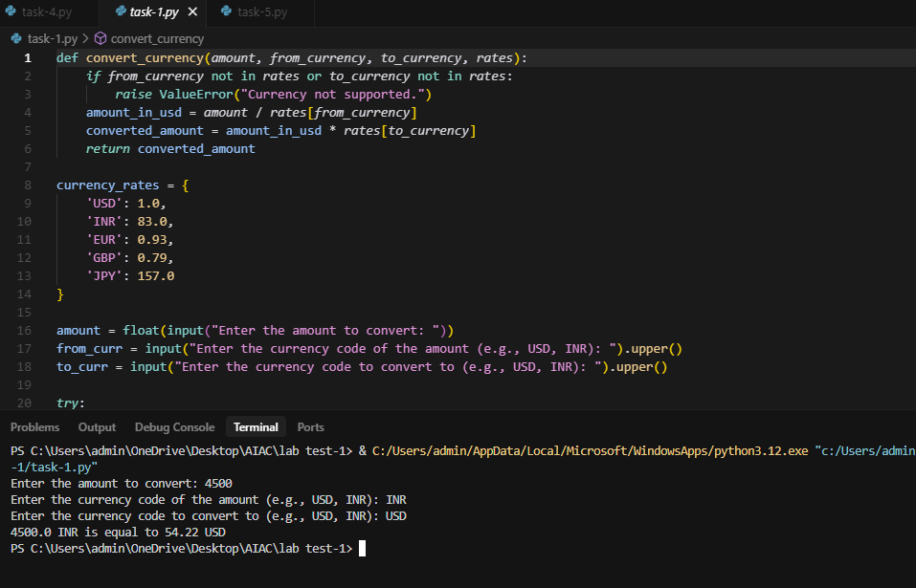

1.Create a Python function that converts an amount from one currency to another using exchange rates stored in a dictionary. Use GitHub Copilot along with VS Code. Use Few shot prompting

Prompt1: Create a Python function named convert_currency that takes four arguments:

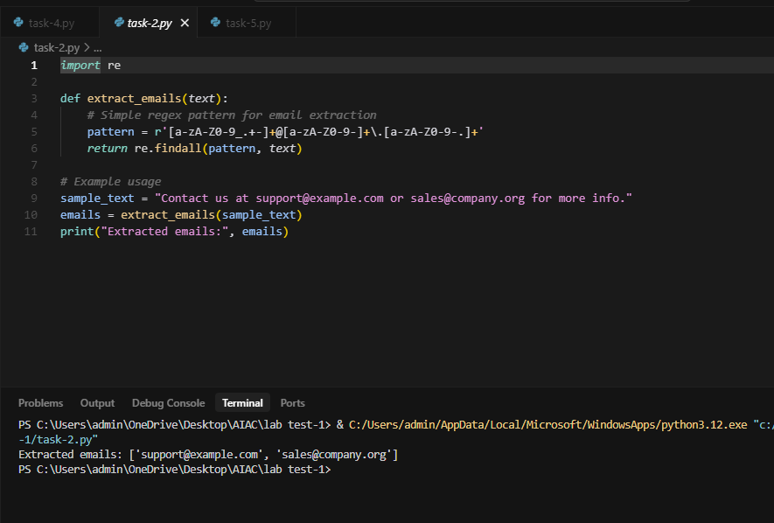

2.Write a Python program to extract all email addresses from a block of text using regular expressions. GitHub Copilot along with VS Code. Use zero shot prompting

Prompt2: Write a Python program that extracts all email addresses from a block of text using the re module. The program should:

* Read a text string
* Use a regular expression to find all valid email addresses.
* Print the list of extracted email addresses.

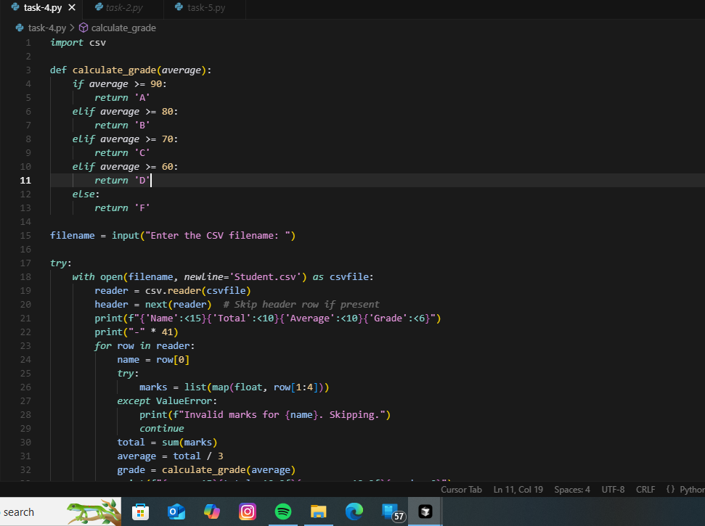

3.Given a list of movies with their genres, Write a Python function that recommends movies based on a user’s preferred genre. Use the Cursor AI tool. Use few shot prompting

Prompt3.: Write a Python function recommend_movies that:

* Takes two parameters:
  1. moviea list of tuples where each tuple contains a string representing the user’s favorite genre.
* Returns a list of movie titles that match the preferred genre (case-insensitive).

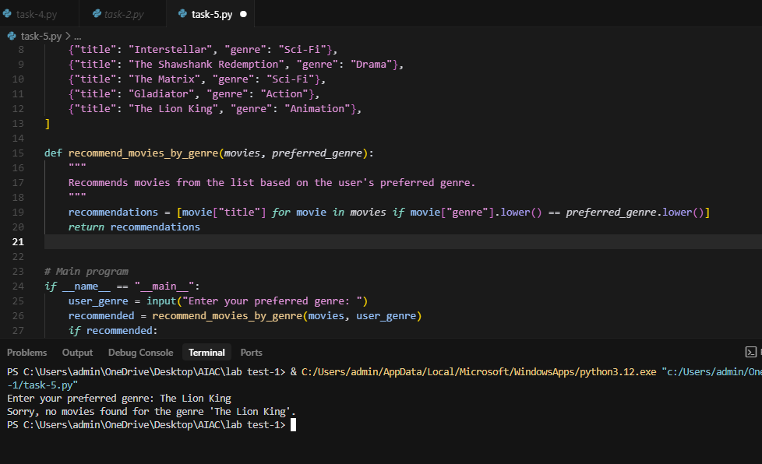

4.Write Python code that reads a CSV file containing student names and marks in 3 subjects. Calculate the total and average marks for each student. Use the Cursor AI tool.

Prompt 4: Write Python code that:

1. Reads a CSV file containing columns: Name, Subject1, Subject2, Subject3.
2. Calculates the total marks for each student.
3. Calculates the average marks for each student.
4. Prints the results in a clear format.